GIT HOL 2
Create .log File and log folder (Untracked)
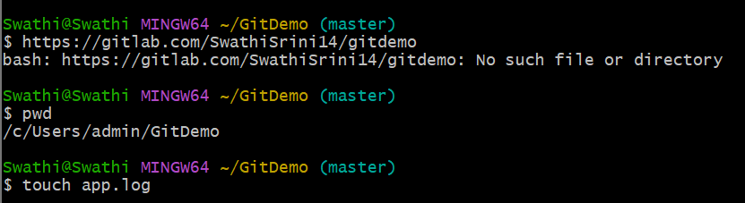
Create .gitignore File
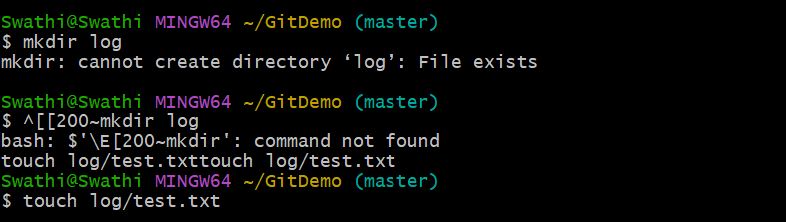
Verify Ignored Files Excluded from git status
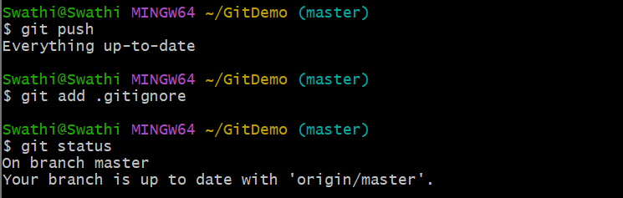
Stage and Verify .gitignore
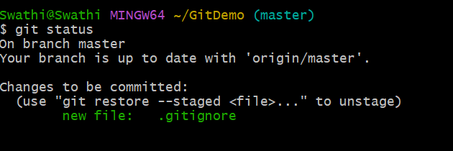
Verify on GitLab (browser)